5. Which type of compound is shown? （ ）
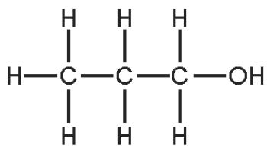
A alcohol B alkane C alkene D carboxylic acid

5. Ethene, propene and butene are all members of the same homologous series.
Which statement explains why ethene, propene and butene have similar chemical properties? （ ）
A They all have the same functional group.
B They are all gases at room temperature.
C They are all hydrocarbons.
D They are all organic.

1. The main constituent of natural gas is hydrocarbon X.
To which homologous series does X belong and how many atoms are in one molecule of X? （ ）
 | homologous series | number of atoms in one molecule
A | alkane | 1
B | alkane | 5
C | alkene | 1
D | alkene | 5

2. Ethanol is a fuel used in cars. It can be made from petroleum.
$$\begin{matrix}C_{4}H_{10}→C_{2}H_{4}+C_{2}H_{6} \\ C_{2}H_{4}+H_{2}O→C_{2}H_{5}OH \\ C_{2}H_{5}OH+3O_{2}→2{CO}_{2}+3H_{2}O\end{matrix}$$
Compounds of how many homologous series appear in these equations? （ ）
A 1 B 2 C 3 D 4

3. Which group of compounds is part of a homologous series? （ ）
A CH₄, C₂H₄, C₃H₈
B C₃H₆, C₃H₈, C₃H₇OH
C CHOH, C₂H₅OH, C₃H₇OH
D CHCO₂H, CH₃CH₂OH, HCO₂H

4. The structures of four molecules are shown.
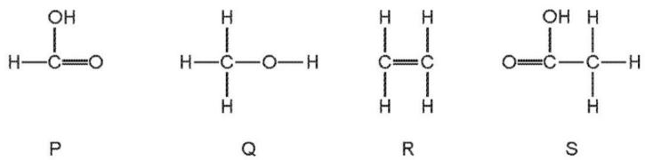
Which two molecules belong to the same homologous series? （ ）
A P and Q B P and S C Q and R D R and S

5. Which row represents compounds in the same homologous series? （ ）
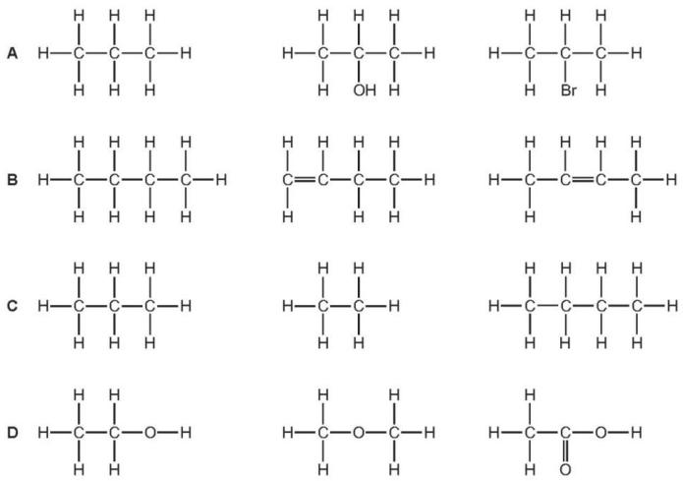
6. The structures of four different organic compounds are shown.
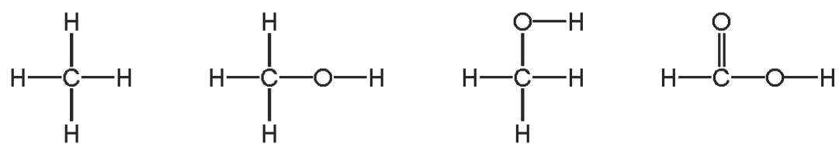
How many different homologous series are represented by these compounds?（ ）
A 1 B 2 C 3 D 4

7.Which homologous series is not represented in the compounds shown below?（ ）
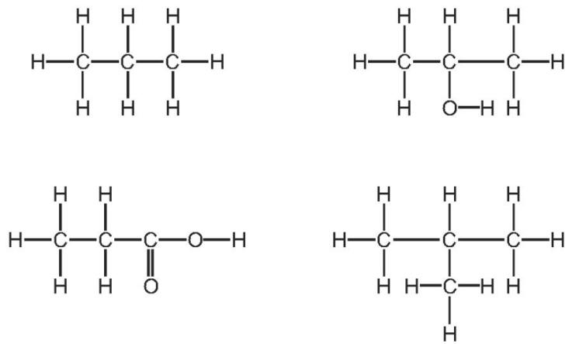
A alcohols B alkanes C alkenes D carboxylic acids

8. The structures of four compounds are shown.
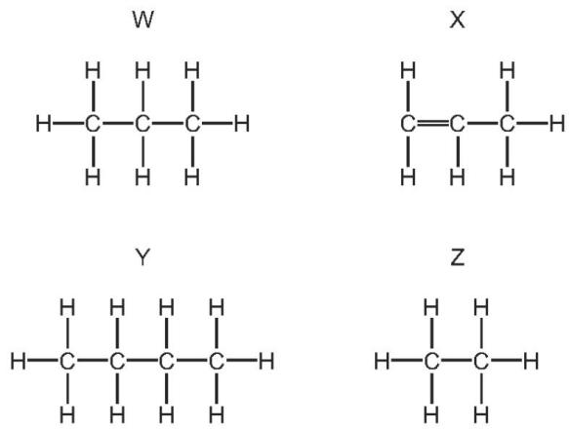
Which are members of the same homologous series? （ ）
A W,X,Y and Z B W and X only C W,Y and Z only D X and Z only

9. Which of the compounds shown are in the same homologous series? （ ）
1 CHOH 2 CHCHOH 3 CHCOOH 4 CHCHOH
A 1,2 and 3 B 1,2 and 4 C 1,3 and 4 D 2,3 and 4

10. Which compound does not belong to the same homologous series as the other three compounds? （ ）
A CHOH B CHCOOH C CHOH D CHOH

11. Which statement about homologous series is not correct? （ ）
$C_{4}H_{21n−2}$A Alkanes have the same general formula,
$CH_{2}$B Each member of the homologous series of alkanes differs from the next by
C The members of a homologous series all have similar chemical properties.
D The members of a homologous series all have the same functional group.

12. Which statement about homologous series is not correct? （ ）
A All homologous series are hydrocarbons
B Members of a homologous series have the same functional group.
C Members of a homologous series have similar chemical properties.
D The alkanes are an example of a homologous series.

13. Which statements about homologous series are correct? （ ）
1 All members have similar chemical properties.
2 All members have the same molecular mass.
3 Ethane and ethene are members of the same homologous series.
4 Ethane and propane are members of the same homologous series.
A 1 and 3 B 1 and 4 C 2 and 3 D 2 and 4

14. Which statement about homologous series is correct? （ ）
A Members of a homologous series have the same structural formula.
B Members of a homologous series all have similar chemical properties.
C Members of a homologous series all have similar physical properties.
D Members of all homologous series are hydrocarbons.

15. Which statement about compounds in the same homologous series is correct? （ ）
A They have the same chemical properties because they have the same number of carbon atoms.
B They have the same physical properties because they have the same number of carbon atoms.
C They have different chemical properties because they have different numbers of carbon atoms.
D They have different physical properties because they have different numbers of carbon atoms.

16. Which statement about a homologous series is correct? （ ）
A All members have the same general formula.
B All members have the same molecular formula.
C All members have similar physical properties.
D Members show a trend in their chemical properties.

17. Two homologous series of hydrocarbons are the alkanes and the alkenes.
One general characteristic of a homologous series is that the physical properties vary in a predictable way.
State three other general characteristics of a homologous series.
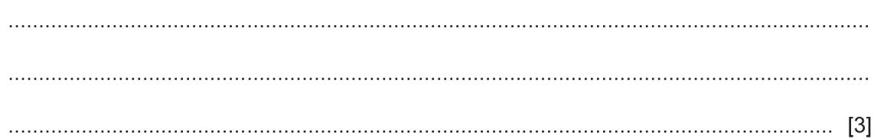
ii.How can the molecular formula of a hydrocarbon show whether it is an alkane or an alkene?
[2]
How do alkanes and alkenes differ in their molecular structures?
Cracking is the thermal decomposition of alkanes into smaller hydrocarbons and possibly hydrogen.
State two conditions required for the cracking of an alkane.
...................................................................................................................................[2]
ii.One type of cracking produces an alkane and an alkene.
Complete an equation for the cracking of heptane into an alkane and an alkene.
$→……………………$C₇H₁₆ + ..................................[1]
Complete an equation for the cracking of heptane into hydrogen and two other products.
$$C_{7}H_{16}→…………+…………+H_{2}$$
Suggest one reason why cracking is important.
$20cm^{3}$$200cm^{3}$$150cm^{3}$$50cm^{3}$Hydrocarbons burn in excess oxygen to form carbon dioxide and water. of a gaseous hydrocarbon burned in an excess of oxygen, . After cooling, the volume of the residual gas at r.t.p. was , of which was oxygen.
Determine the volume of the oxygen used.
..................................................................................................................................[1]
Determine the volume of the carbon dioxide formed.
......................................................................................................................................
The hydrocarbon was an alkane. Determine the formula of the hydrocarbon.
.......................................................................................................................................
18 . An homologous series is a ‘family’ of organic compounds whose names have the same ending.
I. Name the homologous series for which the names of the organic compounds end in -ene and -oic acid.
ene ...........................................................................................................................[1]
oicacid ....................................................................................................................[1]
ii.State two characteristics of an homologous series.
.................................................................................................................................[2]
Propan⁻¹-ol is a member of the homologous series of alcohols. It reacts in the same way as ethanol with acidified potassium manganate(VII) and with carboxylic acids.
Name the type of compound that is formed when propan- 1- ol is heated with acidified potassium manganate(VII), ethanoic acid and a suitable catalyst.
.................................................................................................................................[2]
c.The structure of prop⁻²-enoic (acrylic) acid is shown.
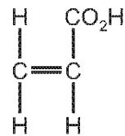
What would you see if prop⁻²-enoic acid were added to aqueous bromine, a solution of sodium carbonate.
.................................................................................................................................
.................................................................................................................................[2]
Prop- 2- enoic acid can be polymerised to form poly(acrylic acid).
Suggest the type of polymerisation that occurs and draw one repeat unit of the polymer. type of polymerisation repeat unit
.................................................................................................................................
.................................................................................................................................

19. Ethanol is a member of the homologous series of alcohols.
Give two characteristics of members of a homologous series.
1 ................................................................................................................................
2 ................................................................................................................................[2]
The structure of ethanol is shown.
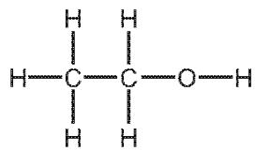
Complete the dot- and- cross diagram to show the electron arrangement in a molecule of ethanol. Show outer shell electrons only.
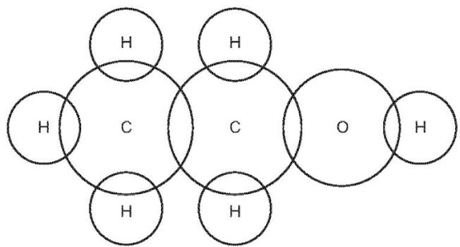
[2]
c.Ethanol can be produced by the catalytic addition of steam to ethene or by the fermentation of glucose.
d.Write a chemical equation for the production of ethanol by the catalytic addition of steam to ethene.
................................................................................................................................[1]
$C_{6}H_{12}O_{6}$ii.Write a chemical equation for the production of ethanol by the fermentation of glucose, .
........................................................................................................................[1]
iii.State one advantage of producing ethanol by the catalytic addition of steam to ethene. Your answer must not refer to cost.
................................................................................................................................[1]
iv.State one advantage of producing ethanol by the fermentation of glucose. Your answer must not refer to cost.
................................................................................................................................[1]
d.Ethanol can be oxidised to ethanoic acid.
State the chemical reagent needed to oxidise ethanol to ethanoic acid.
................................................................................................................................
Ethanoic acid reacts with ethanol in the presence of an acid catalyst. The products are an organic compound and water.
................................................................................................................................
Draw the structure of the organic compound formed.
Show all of the atoms and all of the bonds.

ii.State the name of the organic compound formed.
................................................................................................................................
iii.Which homologous series does the organic compound formed belong to?
................................................................................................................................
................................................................................................................................

